
Checklist For
FAS-PIV

5.4+

4/4/18

DHS Systems Engineering
Life Cycle

Transportation Security Administration

Revision History

Date | Version | Description | Author
4/4/18 | Initial | - FAS-PIV checklist | Nick Hoang -SoftTech Dev Team

Table of Contents
1. Overview 4
2. Procedure 4
2.1 Read the AATE Application On-boarding guide 4
2.2 FAS-PIV is SP initiated SSO 4
2.3 Meeting with the F5 team 4
2.4 Design, review, and get approved the DFD 4
2.5 Map faspiv.tsa.dhs.gov to ITE-PIV (TD) server 4
2.6 Request for Write privilege to ofasapp account 4
2.7 Obtain DHS Dual Test Card 5
2.8 Install a Win10 VD in ITE jump box xxx.200 5
2.9 Configure DHS Dual Test Card with AD 5
2.10 Configure DHS Dual Test Card in Virtual Desktop 5
2.11 Request a code signing certificate for non-production server. 5
2.12 Build a keystore using the certificate 5
2.13 Submit the certificate request to enrollmenttest URL 6
2.14 Import the certificate to the keystore 7
2.15 Obtain the F5 IDP metadata 7
2.16 Implement dual-login FAS-PIV application with Spring Security 7
2.17 Deploy the application to ITE-PIV server 7
2.18 Generate the SP metadata and send it with SP certificate to F5 IdP 8
2.19 Conduct a testing session with the F5 IdP 8
2.20 Debug the application for correct AuthnRequest and SAMLResponse 8
2.21 Successfully log in to FAS using the PIV 8

Overview
The build document lays out the steps involved when building and deploying FAS-PIV application.

- Procedure

Read the AATE Application On-boarding guide
The AATE Application On-boarding guide provides updated information on how to set up, integrate, and test FAS-PIV application with F5 IdP.

FAS-PIV is SP initiated SSO
Since FAS-PIV implements the dual-login option from https://faspiv.tsa.dhs.gov, the FAS application can be accessed from either UserID/Password or PIV authentication.

If PIV Login is selected, the FAS SP will direct the browser to https://saml.tsa.dhs.gov which is the F5 IdP for PIV authentication.

Meeting with the F5 team
Conduct a meeting with the F5 team to layout the tasks to be scheduled and prerequistes. Refer to section 4-work-to-do and Appendix B in the AATE document.

Design, review, and get approved the DFD
For FAS-PIV integration, one ITE server (TD) is utilized to deploy and test the FAS application with the F5 IdP.

DFD details include existing and new infrastructure, network links, Certificates, DNS names, URLs, IP addresses, ports and protocols used and any external linkage.

The development team designs the DFD, sends it to the F5 team for review and comments. The implementation does not start until the DFD is approved. Then the F5 team starts working on the infrastructure configuration.

Map faspiv.tsa.dhs.gov to ITE-PIV (TD) server
The development team requests OED-Test Support to map faspiv.tsa.dhs.gov to ITE-PIV (TD) server via DNS.

Request for Write privilege to ofasapp account
The development team requests OED-Test Support to grant the Write privilege to ofasapp account in order to deploy and configure the FAS-PIV application in ITE-PIV (TD) server.

Obtain DHS Dual Test Card
The development team requests TSA/OED via GPM to obtain valid DHS Dual Test Cards. FAS-PIV application in ITE-PIV requires the use of DHS Test PIV cards

Install a Win10 VD in ITE jump box xxx.200
The developer requests OED-Test Support to install a Win10 VD in ITE jump box xxx.200 in order for F5 IdP to access the Test PIV card.

Configure DHS Dual Test Card with AD
The Test PIV card needs to be linked to a test account in the AD store.

In order to access Win10 VD in ITE, the NETWORK\ DUALxxx.TESTCARD user account needs to be added to the ADM-WKS-AllWorkstations-LclRdu AD Group so that the account can be used to RDP into Windows 10 Virtual Desktop.

Configure DHS Dual Test Card in Virtual Desktop
The developer configures the assigned DHS Dual Test Card

Refer to Test Card local configuration in section 4.2.4 in the AATE document.

Request a code signing certificate for non-production server.
The FAS team requests a code signing certificate for a non-production server from TSA PKI and DHS PKI teams via the ISSO. Form 142-24 PKI DS REQ.

FQDN: faspiv.tsa.dhs.gov

The PKI returns the certificate with Reference number and Authorization code.

Build a keystore using the certificate
Step 1: Create a keystore
with the following commands

keytool -genkeypair -alias faspivsigning -keyalg RSA -keysize 2048 -keystore faspiv.jks

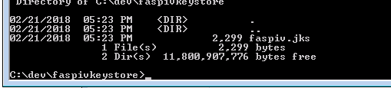

Back it up.

keytool -list -v -keystore faspiv.jks > jks.out

Step 2: Generate a CSR

keytool -certreq -keyalg RSA -alias faspivsigning -file faspiv.csr -keystore faspiv.jks

The faspiv.csr is produced

Submit the certificate request to enrollmenttest URL

ITE: https://enrollmenttest.dimc.dhs.gov/cda-cgi/clientcgi?action=serverCert

Example:

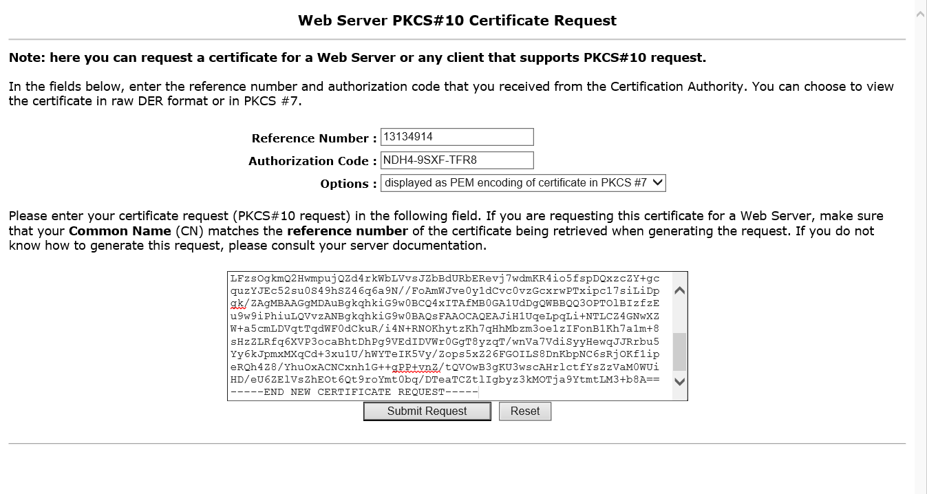

When you hit submit, wait and a certificate will be presented. Below is an example

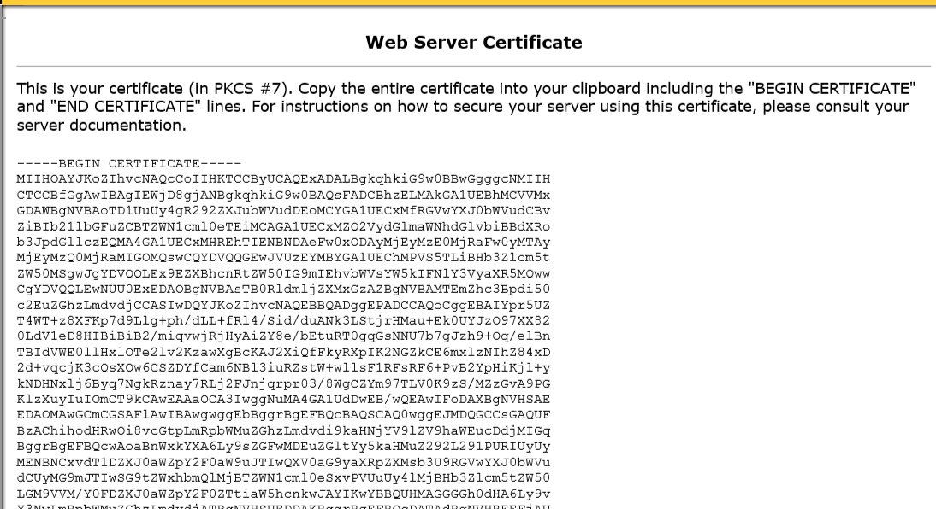

Once you have received your signed codes signing certificate file back, you can install it into the keystore that you created when you created the CSR.

Import the certificate to the keystore

For ITE:
keytool -import -trustcacerts -alias faspivroot -file root.cer -keystore faspiv.jks
keytool -import -trustcacerts -alias faspivinter -file intermediate.cer -keystore faspiv.jks
keytool -import -trustcacerts -alias faspivsigning -file signcert.cer -keystore faspiv.jks

Obtain the F5 IDP metadata
The developer requests the F5 IdP Metadata. It should have the ADMail attribute which will be used to store the TSA email address and IdP public key.

Implement dual-login FAS-PIV application with Spring Security
Implement dual-login FAS-PIV application with Spring Security toolkit, IdP metadata, and SP keystore.

Build the application.

Deploy the application to ITE-PIV server
Login to ITE-PIV server as ofassapp and deploy the FAS-PIV application in JBoss.

Generate the SP metadata and send it with SP certificate to F5 IdP
Use the metadata URL to generate the SP metadata and send it to F5 IdP

Conduct a testing session with the F5 IdP
Make sure the F5 IdP assigns a working instance for FAS-PIV application.

Debug the application for correct AuthnRequest and SAMLResponse
Test the FAS-PIV in Win 10 VD and PIV card.

Enter https://faspiv.tsa.dhs.gov in ITE VD browser
Select PIV Login option.

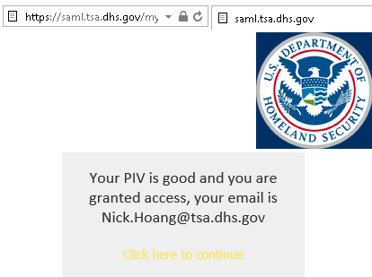

Successfully log in to FAS using the PIV
If the AuthnRequest is sent and SAMLReponse is received successfully, user can access the FAS-PIV home page.

